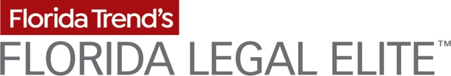

FOR IMMEDIATE RELEASE Contact:
06/28/21 David G. Denor, Florida Trend Publisher
(727) 892-2618; ddenor@FloridaTrend.com

[Name] Recognized as Florida Legal Elite

ST. PETERSBURG, FL – [Name, Firm, City] was recently recognized in the 2021 edition of Florida Trend’s Florida Legal Elite™. The list of 1,263 honorees represents just over 1% of the active Florida Bar members, including attorneys in private practice as well as top government and non-profit attorneys who practice in Florida.
Florida Trend invited all actively practicing Florida lawyers to name the attorneys that they hold in highest regard – lawyers with whom they have personally worked and would recommend to others.
“Florida Trend’s Legal Elite program is an opportunity to celebrate Florida Bar members from a wide range of practice areas who have earned a high level of respect and esteem from their peers. The Florida Bar applauds those who were selected for this prestigious honor, which reflects their commitment to excellence and professionalism in the field of law,” notes The Florida Bar President Michael G. Tanner.

“Now in its 18th year, the Florida Legal Elite, published in Florida Trend's July issue, provides its 270,000 readers with a peer-reviewed resource listing of the best lawyers in the state,” says Publisher David G. Denor.
View the entire Legal Elite roster, including Hall of Fame inductees and top Up and Comers, at www.FloridaTrend.com/Legal-Elite.

# # #

